Optimizing Hospitality: Data-Driven Insights into India's Hotel Economy.

1. Introduction
The hospitality sector in India is currently one of the most vibrant and fast-paced industries in the country. From luxury resorts to budget-friendly stays, the market is incredibly diverse, catering to millions of domestic and international travellers. However, simply having a presence in this market isn't enough anymore. To truly succeed, hotels need to move away from guesswork and start using the massive amounts of data available to them.
This project was designed to bridge that gap. By collecting and analyzing real-world data on pricing, locations, and guest feedback, the goal is to provide a roadmap for hotel owners and stakeholders to improve their services and stay competitive in a crowded market.

2. Problem Statement
- Understand Guest Needs: It’s hard to pinpoint exactly what makes a guest happy or unhappy in different parts of India without looking at thousands of reviews.
- Price Rooms Correctly: Setting the right price is a constant challenge. If it's too high, you lose customers; if it's too low, you lose profit.
- Spot Market Trends: Regional demand changes quickly, and without data, hotels often miss out on growth opportunities in specific cities.

3. Project Objectives
To solve these problems, I set out to achieve the following:
- Analyze Customer Sentiment: Use guest reviews to find out what people actually value—whether it’s service, cleanliness, or location—across different Indian regions.
- Find the Pricing "Sweet Spot": Look at how prices fluctuate and see if there is a direct link between what a guest pays and how satisfied they are.
- Identify Regional Patterns: Focus on Tier 1 cities to see which areas are leading the market and where the demand is heading.

4. Methodology & Technical Implementation
Phase 1: Data Acquisition (Web Scraping)
I developed a custom scraper using Python and Selenium to extract data from Trivago.
- The Process: I used a headless Chrome driver to navigate through 30+ pages per city. Because the site uses "lazy loading," I programmed the script to perform aggressive scrolling and implemented explicit waits (up to 30 seconds) to ensure all hotel cards were fully rendered before extraction.
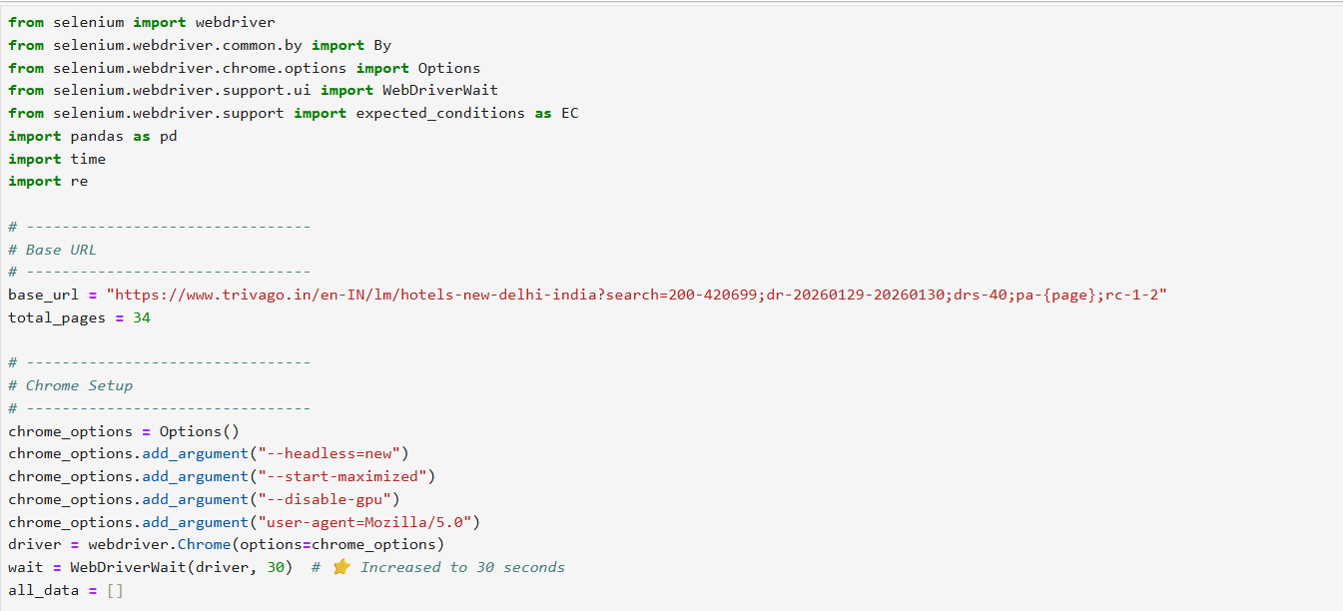
- Extraction: I captured six key data points: Hotel Name, Nightly Price, Rating, Review Text, and Total Review Count.
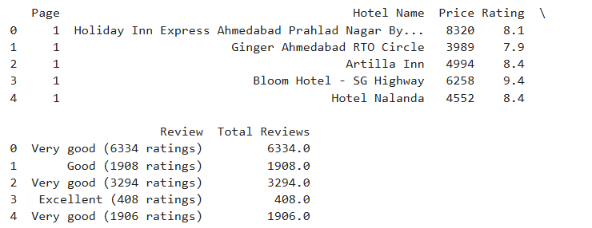
- Scope: I successfully scraped data for 8 major cities, including Mumbai (1,024 hotels), Bengaluru (1,222 hotels), and New Delhi (1,140 hotels).
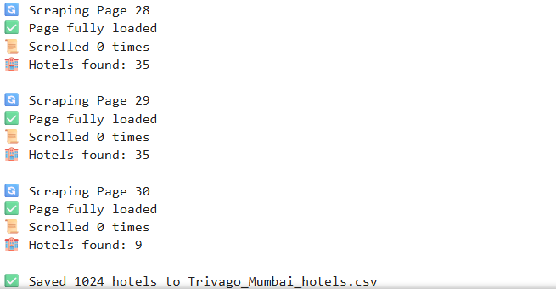
Phase 2: Data Cleaning and Preparation
Raw data from hotel sites is often messy. I used Pandas and NumPy to transform this into an analysis-ready format:
- Feature Engineering: Created a Rating_status column that categorized hotels into "High," "Medium," "Low," or "No Rating" based on their scores.
- Data Cleaning: Utilized python libraries like Pandas and NumPy in identifying and removing duplicates hotels.
- Column Standardization: Renamed columns to snake case for better readability and documentation.
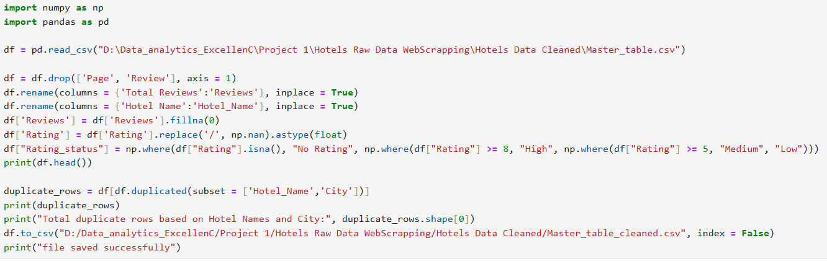
- Standardization: I used Regular Expressions (Regex) to strip currency symbols and non-numeric characters from price and review columns, converting them into proper integers and floats.
- Master Table Creation: I utilized the glob library to merge individual city CSV files into one unified Master Table, ensuring there were zero duplicate rows based on the Hotel Name and City combination.
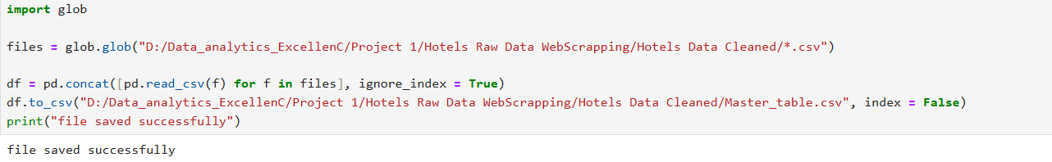
5. Dataset Overview & Dimensions
After completing the extraction and cleaning process, I consolidated all regional data into a single, high-quality Master Table. This dataset serves as the backbone for all subsequent business queries and visualizations.
Data Scale and Structure
- Total Volume: The final cleaned dataset contains 6,555 hotel records.
- Attributes: Each record is defined by 6 specific columns:
  - Hotel_Name: The identifying name of the property.
  - City: The metropolitan area where the hotel is located.
  - Price: The nightly room rate (ranging from a minimum of 544 to a luxury high of 70,622).
  - Rating: The guest satisfaction score, standardized on a scale of 1.0 to 10.0.
  - Reviews: The total volume of feedback received, which acts as a key indicator of property popularity.
  - Rating_status: A custom categorical feature I engineered to segment properties into "High," "Medium," "Low," and "No Rating".
Regional Breakdown (Hotels per City)
The data is heavily focused on major Indian economic hubs, providing a robust sample size for Tier 1 city analysis:
- Bengaluru: 1,215 hotels
- New Delhi: 1,136 hotels
- Mumbai: 1,019 hotels
- Chennai: 696 hotels
- Hyderabad: 646 hotels
- Kolkata: 642 hotels
- Pune: 636 hotels
- Ahmedabad: 565 hotels
Data Quality: The "No Rating" Segment
A significant part of my analysis involved identifying hotels that are active in the market but have not yet established a guest rating.
- Observation: Out of the total dataset, 1,945 hotels were identified with a status of "No Rating".
- Significance: Categorizing these hotels separately ensures that my average satisfaction scores are not skewed by zero-values. It also highlights a massive segment of the market—nearly 30%—where hotels could potentially benefit from better digital engagement strategies to encourage guest feedback.
6. Data Analysis & Business Insights (SQL Results)
After the data cleaning phase, I executed a series of targeted queries in SQL Server to transform the raw data into business intelligence. Below are the key areas I identified:
Market Overview (City Level Analysis)
1. Identified that Bengaluru (1,215), New Delhi (1,136), and Mumbai (1,019) have the highest concentration of hotel inventory in this study.
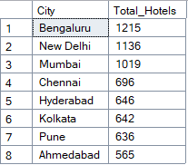
2. % market shares of each city: By calculating market share, I found that the top three cities (Bengaluru, Delhi, Mumbai) dominate over 50% of the total hospitality landscape.
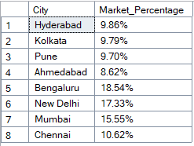
3. Average price by city: This query highlighted the "Premium" markets, showing which cities command higher nightly rates on average.
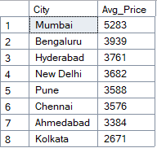
4. Average rating by city: I discovered which regions maintain the highest standards of guest satisfaction.
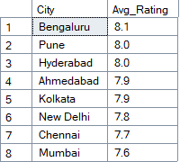
5. Total reviews by city (demand indicator): New Delhi, Mumbai and Bengaluru showed the highest total review counts, indicating they are the busiest hubs for guest traffic.
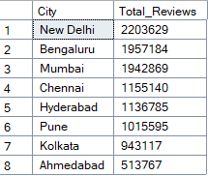
Pricing Strategy Analysis
1. Overall price statistics: I established a price baseline with a minimum of 544 and a maximum of 70,622, using the Median Price to identify the "true" middle market.
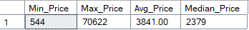
2. Price segments (Budget / Mid / Luxury): I categorized the data into Budget, Mid-range, and Luxury. This revealed that while luxury hotels are fewer in number, they often maintain more consistent ratings.
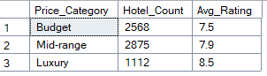
3. Best value hotels (low price + high rating): I identified top-performing hotels that maintain high ratings (8+) despite having lower price points.
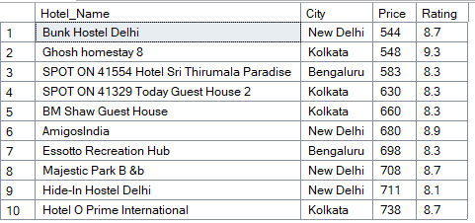
4. Top 10 most expensive hotels: I queried the dataset to identify the top 10 properties with the highest nightly rates across all cities.
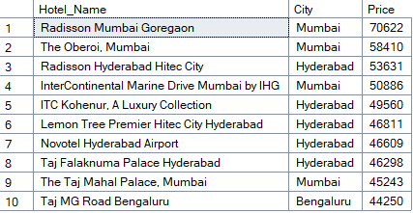
5. Cheapest hotels with good ratings (>8): This query reveals the "Hidden Gems" of the Indian hospitality market. These properties, largely found in New Delhi, Kolkata, and Bengaluru, offer premium experiences at extremely low-price points (ranging from 544 to 738 INR). For example, the Bunk Hostel Delhi maintains a high rating of 8.7 despite being one of the most affordable options in the dataset.
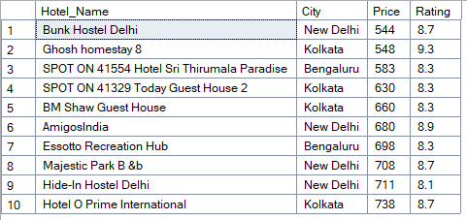
Customer Satisfaction & Service Gaps
1. High price but low rating (bad value): I flagged hotels with prices above 5,000 but ratings below 7. These properties are at risk of losing customers to better-rated competitors.
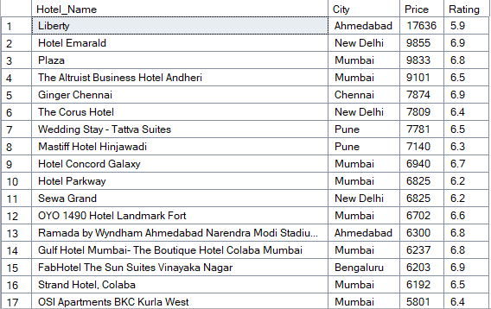
2. Hotels with many reviews but low ratings (service issue): I identified high-visibility hotels (over 1,000 reviews) that have low ratings, suggesting a failure to scale service quality with high guest volume.
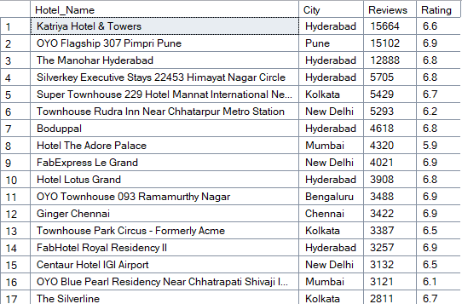
3. Rated vs Unrated Hotels Analysis (Customer Engagement & Pricing): Nearly 30% of the dataset (1,945 hotels) are unrated. I identified which cities have the most unrated hotels, pointing toward a need for better digital engagement.
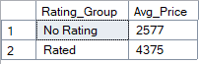
4. Cities have the most unrated hotels: I Identified each city having unrated hotels.
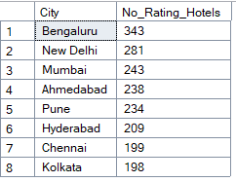
5. Worst value hotels (high price + low rating): I specifically queried the top 10 hotels that carry a Rating of less than 6 while simultaneously commanding the highest prices in the dataset.
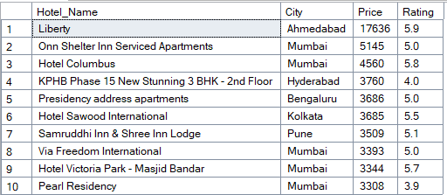
6. Best value hotels (low price + high rating): I queried the top 10 hotels that maintained a Rating of 8 or higher (Excellent/Very Good) and sorted them by Price in ascending order.
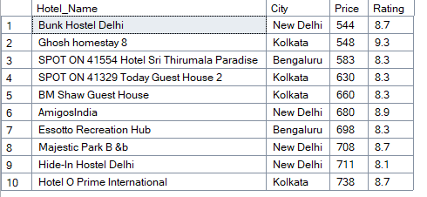
7. Rating distribution: I analyzed the frequency of hotels within specific rating "bands" (e.g., all hotels rated between 7.0–7.9, 8.0–8.9, etc.) to understand the overall quality distribution of the Indian hospitality market.
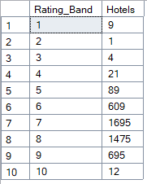
8. Low-rated hotels (<6): I queried the dataset to isolate hotels with a rating below 6.0, which represents the bottom tier of guest satisfaction in the Indian hotel economy.
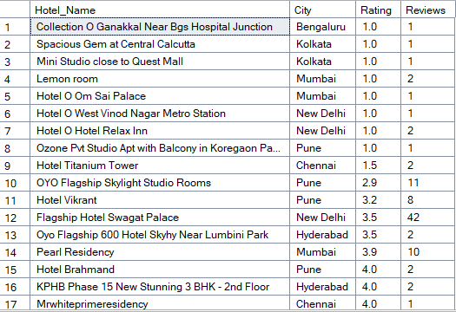
9. Average rating by price segment: I categorized the hotel market into three distinct economic segments—Budget (2,000 INR), Mid-range (2,000–5,000 INR), and Luxury (5,000 INR)—to analyze the correlation between price and guest satisfaction.
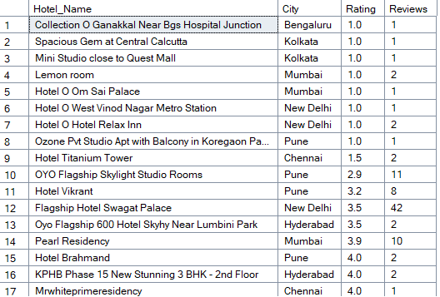
10. Relationship and Correlation Analysis (Price, Rating, and Reviews): I extracted the core numerical attributes—Price, Rating, and Reviews—for all properties where a rating was available. This query serves as the foundation for statistical correlation analysis and scatter plot visualizations in Power BI.
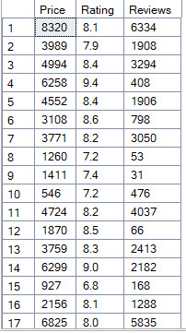
Demand & Popularity (Reviews Analysis)
1. Most reviewed hotels: I queried the dataset to identify the properties with the highest volume of guest reviews. In this analysis, review count serves as a primary proxy for market demand and popularity.
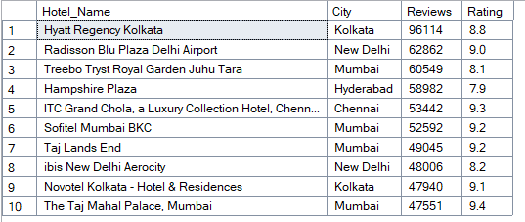
2. Reviews per city: I aggregated the total and average review counts for each city to measure guest engagement and overall market demand. In the hospitality sector, a high volume of reviews is a strong indicator of "Market Heat" or popularity.
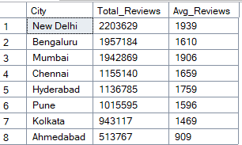
7. Data Visualization: Power BI Dashboards
I developed a professional two-page interactive report in Power BI. This setup allows stakeholders to explore the Indian hotel economy at both a macro and micro level using drill-down and cross-filtering features.
Page 1: National Hospitality Overview
This page serves as the executive summary of the hospitality landscape across India.
- National KPI Dashboard: Displays the total scale of the project, covering 6,555 hotels.
- Market Composition: Visualizes the distribution of hotels across the 8 cities, with Bengaluru (1,215) and New Delhi (1,136) identified as the largest markets.
- Pricing Segmentation: A breakdown showing the concentration of properties in Budget, Mid-range, and Luxury tiers.
- Rating Health: Highlights the significant 1,945 unrated hotels, identifying a massive segment for digital improvement.
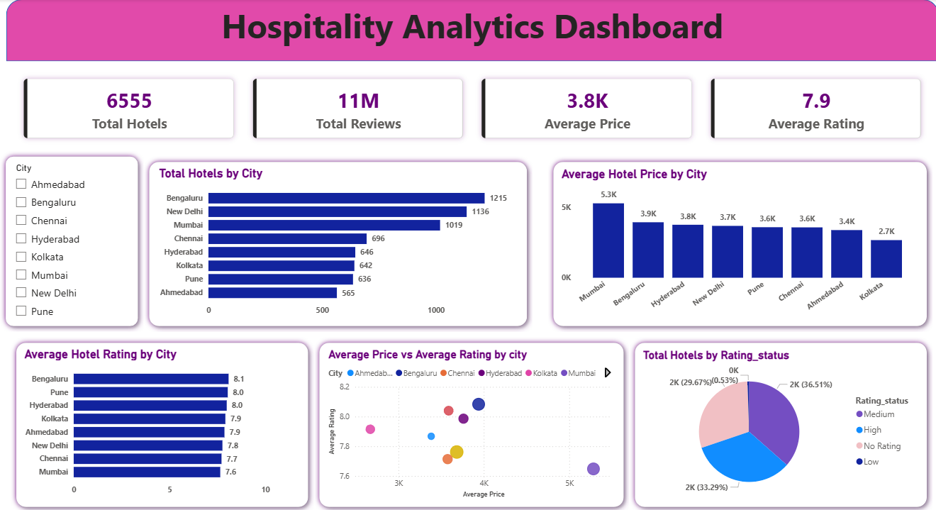

Page 2: Tier 1 City Drill-Down & Analysis
The second page provides the granular detail required by the project brief for Tier 1 cities.
- Drill-Down Functionality: Users can select a specific city (e.g., Mumbai or Bengaluru) to instantly filter all visuals to that location.
- Factors Analyzed: In-depth analysis of Price vs. Ratings and Total Reviews to identify local demand patterns.
- Best & Worst Value (Dynamic Tables): These tables update based on the city selection to show the top 10 Best Value (low price, high rating) and Worst Value (high price, low rating) properties specifically for that region.
- Review Volume Correlation: Visualizing which localized areas have the highest guest engagement.
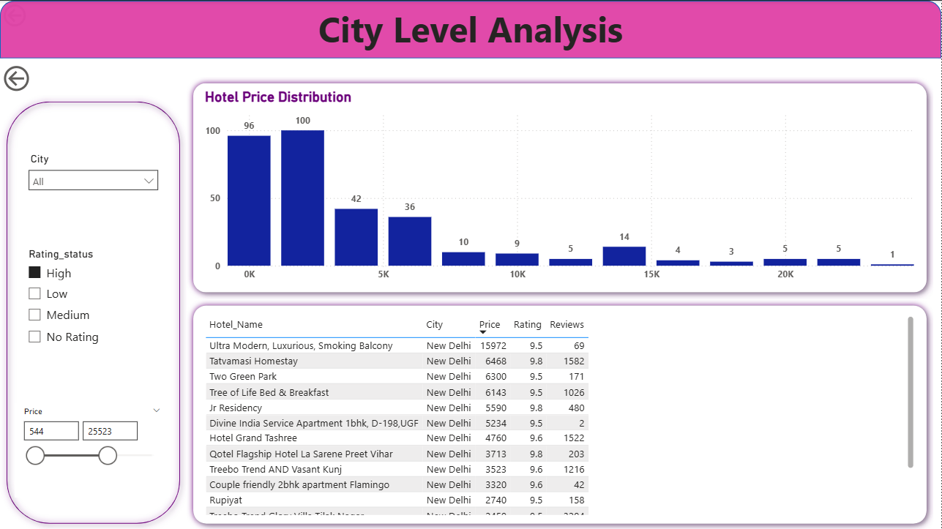

8. Business Recommendations
Based on the data-driven insights gathered from over 6,555 hotels, I propose the following strategic recommendations for stakeholders in the Indian hotel economy:
1. Bridge the "Digital Gap" for Unrated Hotels
- Observation: I identified 1,945 hotels (nearly 30% of the dataset) that currently have "No Rating".
- Recommendation: Booking platforms and hotel management should prioritize guest engagement campaigns. Encouraging just a few reviews can significantly move these properties into a "Rated" status, which historically increases booking confidence and allows for better price positioning.
2. Target the "Service Gap" in Major Hubs
- Observation: Cities like Mumbai and Chennai have the lowest average ratings in the dataset (7.6 and 7.7 respectively).
- Recommendation: Investors and management in these cities should focus on service quality audits. Since these are high-demand Tier 1 cities, improving the guest experience even slightly could allow properties to shift from "Medium" to "High" status and justify higher nightly rates.
3. Competitive Pricing for "Best Value" Positioning
- Observation: My analysis identified a "High" rating status for hotels averaging around 6,246 INR, but many "Medium" rated hotels are priced much lower at 2,707 INR.
- Recommendation: Mid-range hotels should aim for the "Best Value" sweet spot. By keeping prices competitive while maintaining an 8+ rating, properties can capture market share from the "Worst Value" luxury hotels that are overcharging for sub-par experiences.
4. Regional Inventory Optimization
- Observation: Bengaluru and New Delhi have the highest inventory and the most unrated hotels.
- Recommendation: In these saturated markets, differentiation is key. New properties should focus on niche offerings or superior loyalty programs to stand out amongst the 1,000+ competitors in their specific city.

